**Lifecycle Hooks**

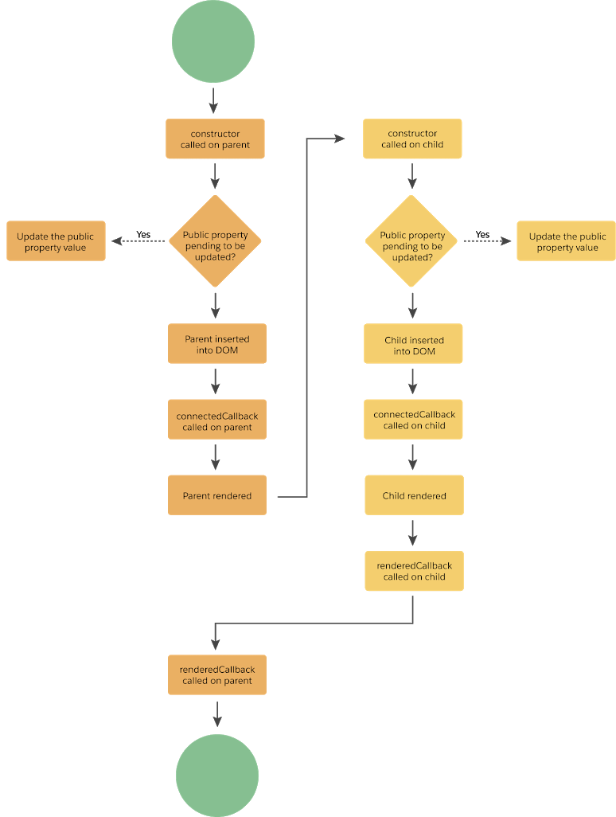

Lightning Web Components provides methods that allow you to “hook” your code up to critical events in a component's lifecycle. These events include when a component is:

**constructor()**

You should use the **constructor()** hook when you need to do any of the following:

1. Initialize state: If you need to initialize the state of a component, you can do it in the **constructor()** hook.
2. Set up resources: If you need to set up any resources, such as a timer or an event listener, you can do it in the **constructor()** hook.
3. Perform one-time initialization: If you need to perform some one-time initialization, such as retrieving data from an external service, you can do it in the **constructor()** hook.

It's important to note that the **constructor()** hook is not always necessary. In many cases, you can initialize state or set up resources using other hooks like **connectedCallback()** or **renderedCallback()**. However, if you need to do any one-time initialization or set up any resources that need to be cleaned up when the component is destroyed, the **constructor()** hook is a good place to do it.

**connectedCallback()**

**here the component is not render yet, so**

Rendered in the browser **renderedCallback()**

Encountering errors **errorCallback(error, stack)**

Removed from the DOM **disconnectedCallback()**